English Klingon Dictionary



***leng tlhIngan tera' mu'ghom***

Create a Visual Studio solution that produces the following form.

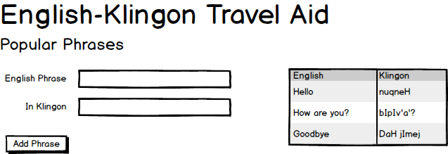

The Visual Studio solution should

* Include appropriate navigation menus
* Use a class library for the class called **Translation**
* Show the current translations in a GridView on the side of the page.